**Circulatory System**

* Heart, blood vessels, and blood
* **Pulmonary** (branch in to 2) & **systemic** (branch into many for many organs) circulation
  + ~ muscular system 25%, nervous 15%, digestive 25%, renal 25%

**Anatomy of the Heart**\* (label parts)

* Located in **thoracic cavity** (chest) in between the **sternum** (breastbone) anteriorly and the **vertebrae** (backbone) posteriorly, press on the bones to do CPR
* Diagram

  Description automatically generatedBase (top) to the right, **apex** (bottom tip) to the left; feels apex (ventricle beats harder)
* Valves:
  + **Atrioventricular** valves: right – **tricuspid** (3 cusps), left – **bicuspid** / mitral
    - Held back by **chordae tendineae** and **papillary muscle**
  + Aortic / pulmonary valves (**semilunar**) – 3 cusps
    - Held back by backwards pressure (not as strong) and anatomical structure
  + No valves between atria and veins
    - atrial pressures not much higher than venous pressures
    - during atrial contraction where vena cava enters atria partially compressed
  + **Fibrous skeleton**: 4 interconnecting rings of dense connective tissue
    - Diagram

      Description automatically generatedSingle plane that separates both atrium from ventricles, provides structure for cardiac muscle and valves (all 4 valves lies on the same plane)
* Wall: 3 layers + muscle
  + **Endothelium**: thin inner layer, special epithelial tissue, circulatory system
  + **Myocardium**: middle layer, composed of cardiac muscle, heart wall
    - Dominates heart contraction – spiral ring like structure, squeeze up
    - **Functional syncytium**: connected by **intercalated discs**, contracts in sync
      * Gap junctions (electrical) and desmosomes (mechanical)
      * Atria and the ventricles each form separate functional syncytium
      * Specialized conduction system between atria & ventricle
    - Entire heart contraction is **all or none**, can only control gradation
  + **Epicardium**: thick external layer, covers the heart
  + 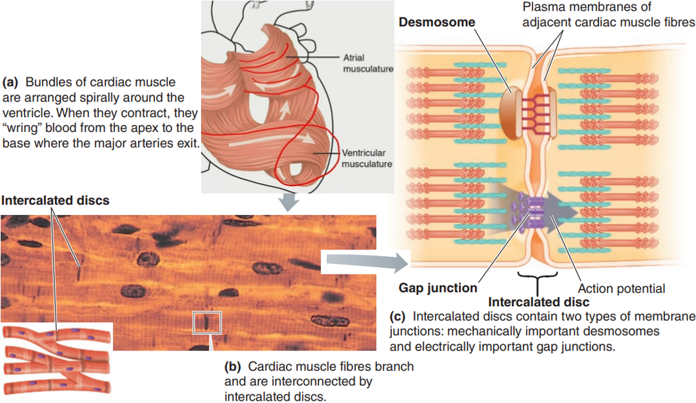**Pericardium** (pericardial sac), double layered membrane, secrete **paracardial fluid** into paracardial cavity (between inner layer and epicardium, protection)

**Electrical Activities of the Heart**

* **Contractile** (99%) vs **Autorhythmic** (SA node, AV node, Bundle of His & Purkinje fibers) cells
* **Autorhythmicity**: heat beats (contracts) at its own, self generated rhythm
* Cardiac Excitation-Contraction Coupling:
  + Calcium enter cytosol through **L-type channels in T tubules**
  + Triggers **ryanodine receptors** (not dihydropyridine receptors in skeletal muscles) on SR to release calcium
  + After contraction, Ca–ATPase pumps calcium back to SR, a secondary pump (Ca out Na in, primary is Na-K pump that pumps Na out) pumps **Ca back to ECF**
* **Cardiac muscle AP**: characterized by long refractory period (plateau), can’t summate
  + Not enough Ca to interact with all troponins (unlike skeletal)
    - ↑ intracellular Ca => ↑ crossbridges => ↑ strength of cardiac contraction
  + **Depolarization**: still by Na influx
  + Chart, line chart

    Description automatically generated**Plateau**: primarily by slow L-type Ca channel (Ca in, maintain depolarized)
  + 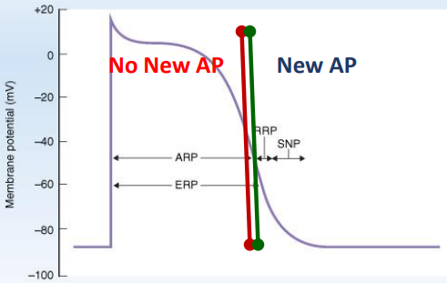**Elongated absolute refractory**: Na channel inactivated due to maintained high potential, summation and tetanus impossible
    - AP lengths:
      * Atria: 150 ms
      * Ventricles: 250 ms
      * Purkinje fibers: 300 ms
      * Skeletal: 1-2 ms
    - **ARP** (absolute): Na channel inactive, can’t fire again
    - **ERP** (effective): at the end of ERP Na channels begin to recover but still insufficient to fire
    - **RRP** (relative): need greater stimulus to fire, new AP have shorter plateau
    - **SNP** (**Supranormal** **Period**): more excitable (higher potential)
  + **Repolarization**: still K efflux, slow & fast, slow is what causes repolarization
  + **No hyperpolarization**: K efflux is slow
  + Resting potential: maintained by inward rectifier K channel ( in graph is outward rectifier K), which is unique as it can move K both in and out of the cell